Course Materials Ordering Process for University Campus Faculty

We use the Barnes and Noble Adoption Tool to place the course materials orders for courses taught at the main campus. The days of the paper/pen order forms are gone! It is our hope that this system will expedite the ordering process and make it easier for all of us. Please submit your Campus orders on or before the deadlines given. (Typically April 15th for Fall Semester / October 15th for Spring Semesters)

On time ordering ensures that buy backs are available for the students, and that we have competitive pricing in place for the future terms.

To access the link through OKTA you will log into the Bookstore portal:

https://saintleo.okta.com/app/UserHome

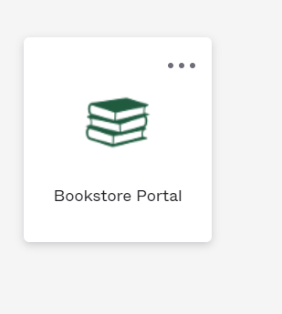

Once you access the Bookstore Portal, the courses you are scheduled to teach in the future Semester at the main campus will appear. You will then enter the required course materials for your courses and submit them within the system. If your class does not require a textbook, please submit that information in the system so we can post a notice for your students.

If you have questions about the materials required for your course or courses, please feel free to contact our Textbook Resource Coordinators. (student.textbooks@saintleo.edu College of Arts and Sciences / Traci.Dunlap@saintleo.edu College of Business / Jessica.moreira@saintleo.edu College of Education and Social Services.) If you want to know what was ordered for a course the last time it was offered or you do not have access within the Barnes and Noble Adoption Tool please contact me for assistance. (abbie.luoma@saintleo.edu)

Thank you in advance for your help with the course materials orders.

