​Deep Linked Assignments and The Gradebook

FAQs:

Q. When will assignment gradebook columns be created and appear?
A: They will appear once the assignment grades sync to the gradebook.

Q: How can I add my deep-linked assignments into the gradebook?
A: This can be completed by clicking on the assignment item. Please see the instruction steps on the next page.

Q: Will the students still have to click on the specific assignment deep link in order for the grade to sync?
A: The students no longer have to click on the specific assignment link to sync the grades.

How to add my deep-linked assignments into the gradebook:

For each item that needs to be graded, click on an assignment item. If the assignment opens in a new tab, close that tab to get back to the course.
Click on Assessment > Add a grade item…
Example:

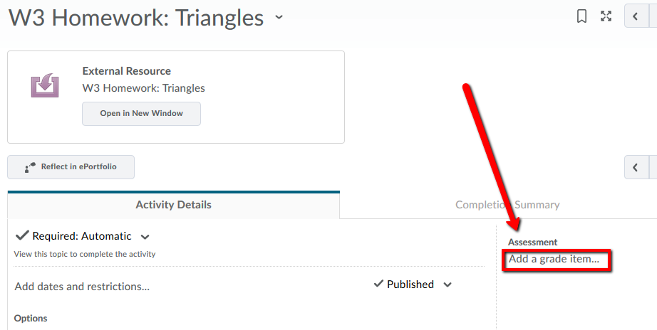
Click on the “+” button to create a new grade item.
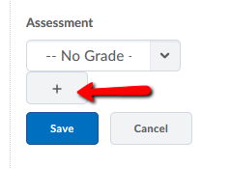

On the New Grade Item form, complete the following fields:
New Grade Item / Name = Assignment Title
Category = select appropriate if present
Maximum Points = reference the assignment CSV or integrated platform for this
Click the “Create” button.
Example:
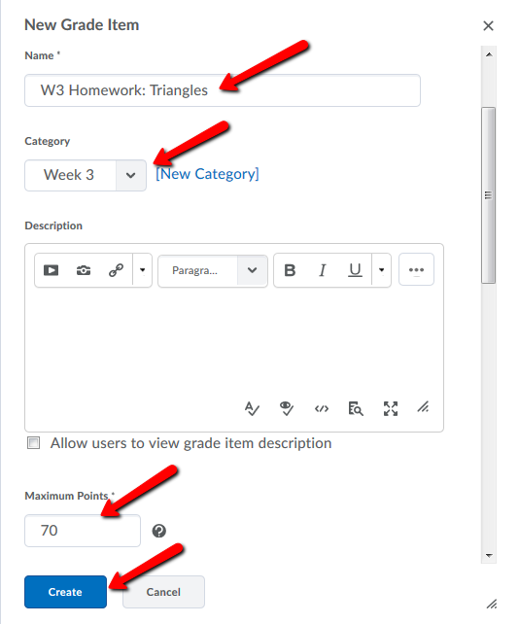

**Remember to click the Save button on the Assignment Screen**

