Last Minute Desk Copy Solution

If you are assigned a new course just before the start of the term, or you need to review a textbook quickly, we have a solution that might work for you. Vital Source (formerly CourseSmart) gives faculty the opportunity to build a digital bookshelf, request desk copies, and view instructor resources from multiple publishers on one platform. To access an existing account (many of you already have one, but may not realize it) or create an instructor account you will follow the instructions listed here.

Go to: https://www.vitalsource.com/educators
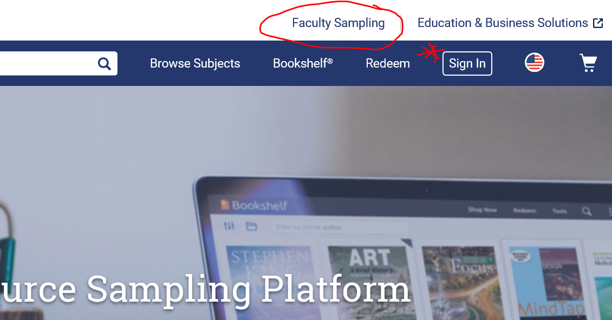

There is a simple process to follow and registration takes only a few minutes. You can begin building your bookshelf right away and requesting your desk copies. If you receive a message that says “pending Publisher approval” this takes about 24-48 hours. If you need to expedite this process email abbie.luoma@saintleo.edu and she will contact our assigned rep for that title to approve your request right away.
From this page you can also request a desk copy:

One you are set up in the system there is a direct link to the bookshelf sign in page for quick access:
https://bookshelf.vitalsource.com/#/user/signin
This will take you to all the books that you have available on your shelf. You will also have the opportunity to select/request additional titles.

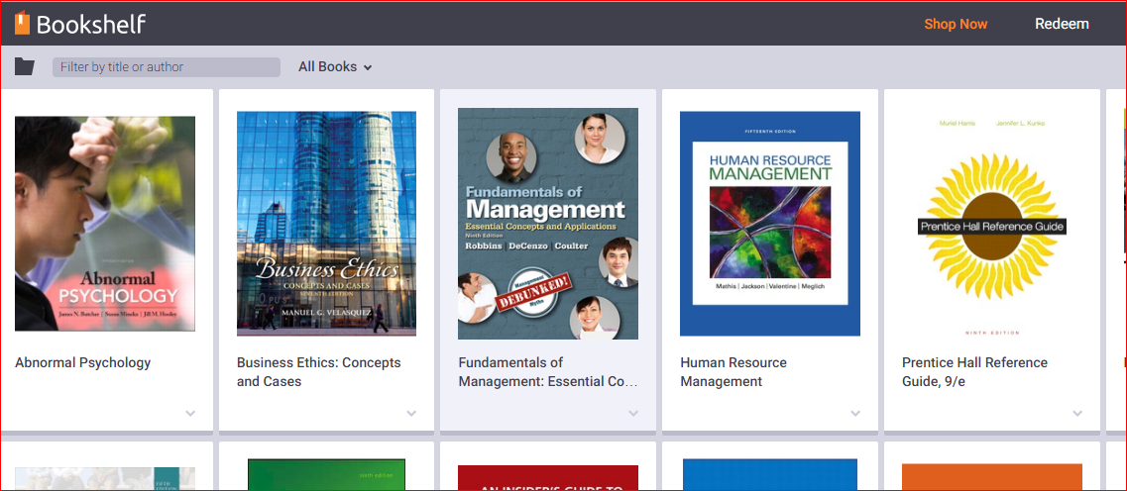

If you would prefer to watch a video that explains the terms and use of Vital Source please access the video link listed here:

https://www.youtube.com/watch?v=YMG2OzMiKCA

Thank you,

