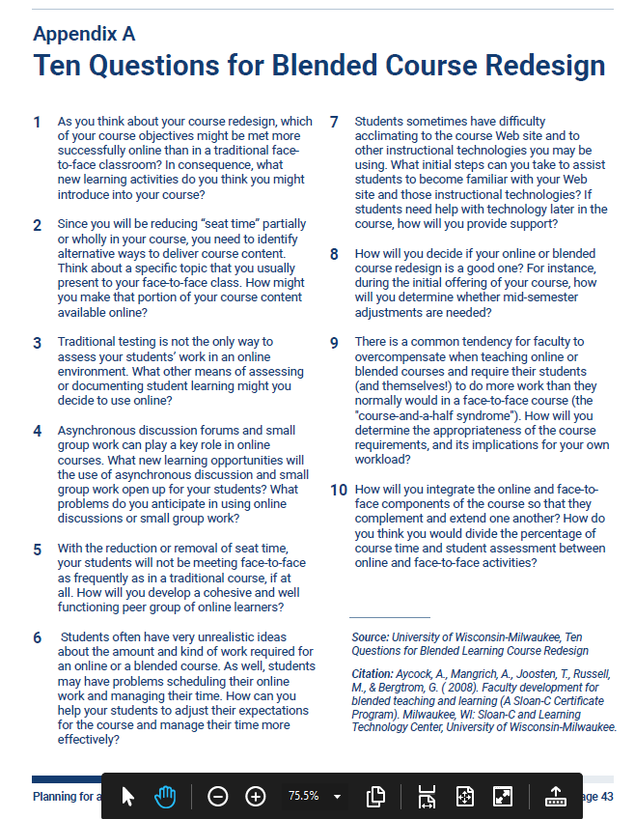
Joosten, T., Weber, N., Baker, M., Schletzbaum, A., & McGuire, A. (2021). Planning for a Blended Future: A Research-Driven Guide for Educators. [Report] Every Learner Everywhere Network. Retrieved from: https://www.everylearnereverywhere.org/resources/

